**Connor Perron**

**BCS426**

**Prof. Aydin**

**Spring 2021**

**Question 1: Implementing an Extension Method**

**Your job is to write an extension method called toRoman to convert and int to its roman representation so that a client code such as below would work.**

**static void Main(string[] args)**

**{**

**int i = 99;**

**string s = i.toRoman();**

**Console.WriteLine(s);**

**}**

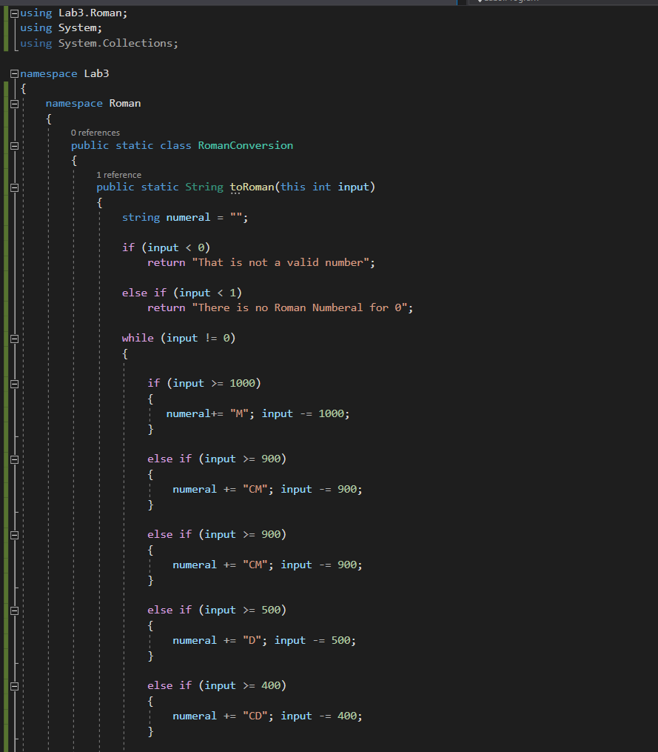

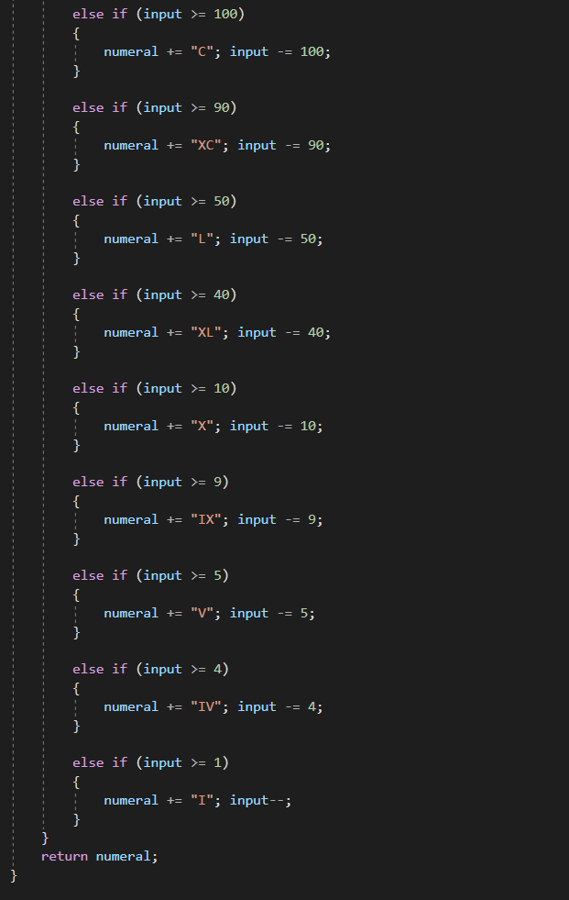

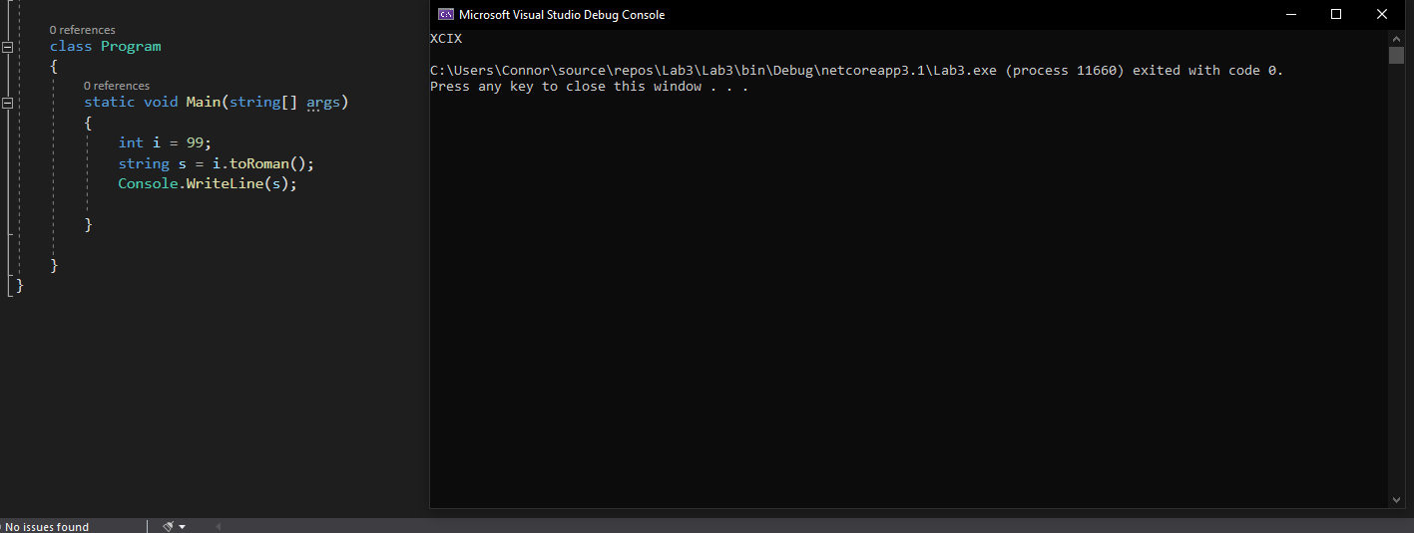

**QUESTION 2: Abstract classes and Interfaces (Review** [**Week 4 - Chp 4 slides**](https://drive.google.com/drive/folders/1-voMzBRitOdXiBNl8SrMm_WM-CbnhxQD?usp=sharing)**)**

* **Create an abstract class Product with following** 
  + **Properties Price (Decimal), Code (string), Description (string)**
* **Create an interface ISellable with the following**
  + **Method sell that takes the count of the products to sell and returns the cost**

**public decimal sell(int count);**

* **Create a concrete class Book that** 
  + **Inherits from class Product**
  + **and implements interface ISellable**
  + **Has additional Property Author (string)**
  + **Add a constructor with parameters, and ToString method to display all of data of class Book**
* **Similarly, create anot concrete class Software that** 
  + **Inherits from class Product**
  + **and implements interface ISellable**
  + **Has additional Property Version (string)**
  + **Add a constructor with parameters, and ToString method to display all of data of the class Software**
* **Finally, write a client code (main program) that will utilize the class and interface hierarchy you created.**
  + **Create two Book objects for the following books**
    - ***C# 8.0 in a Nutshell, with price $50.99 and with ISBN 978-1492051138 by Jack Smith***
    - ***C#: Advanced Features and Programming Techniques, with price $2.99 and with ISBN 100-1492051000 by Jill Smith***
    - **Ask the user how many of each book the user wants to buy and then display a report of how much the total cost is.**
  + **Create a Software object for the following Software**
    - ***Microsoft 365 Personal with price $69.99 and version 16.0.10827***
    - **Ask the user how many of the Microsoft 365 the user wants to buy and then display a report of how much the total cost is.**

